**TOPIC: Ai Bank chatbot**

Key features

1. create an account
2. money transfer
3. Information about loan policies
4. credit card application and cancellation
5. Information about insurance policies
6. Feedback collection

Software used: Chatfuel

Benefits:

* This chatbot is user friendly and privacy of the chat is maintained.
* In this project we used the Standard API to maintain a good connection/interaction between the clients and chatbot.

Procedure:

1. Firstly, the chatbot welcomes the user with greeting. Then it displays a list of features which the user can get from the chatbot and then he/she is asked to choose the option or else user can type.

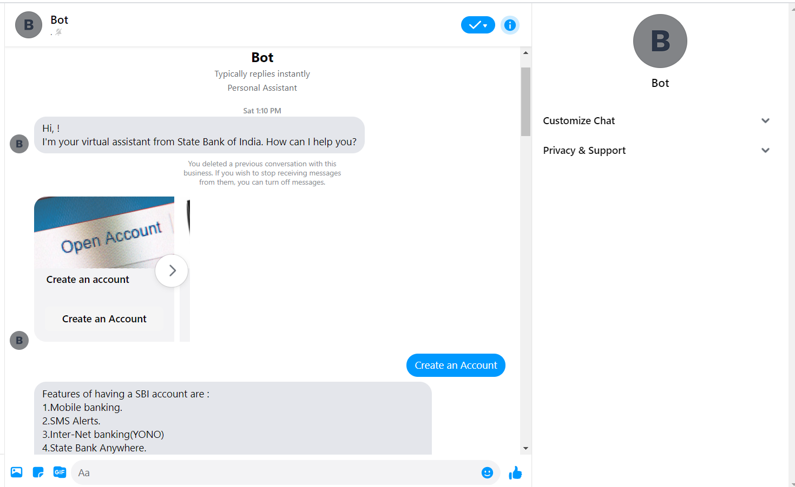

1. According to the choice of the user, it will be give the required information and if the user is unable to get through the interface, they can just type whatever they wants. The chatbot will provide them a direct interface with a link and from this step user can continue.
2. For example: the user has selected to create an account. Now the chatbot will show the features/benefits and what are the required documents for having an account in that bank.
3. Also, a list of different types of account for which the user can apply will be displayed, and can get more information about the type of account and it’s features. (screenshots of the chatbot are under **OUTPUT**)
4. If user clicks on apply, he/she will be directed to a page where he/she needs to enter required details and after sometime the user will be notified about the application status .

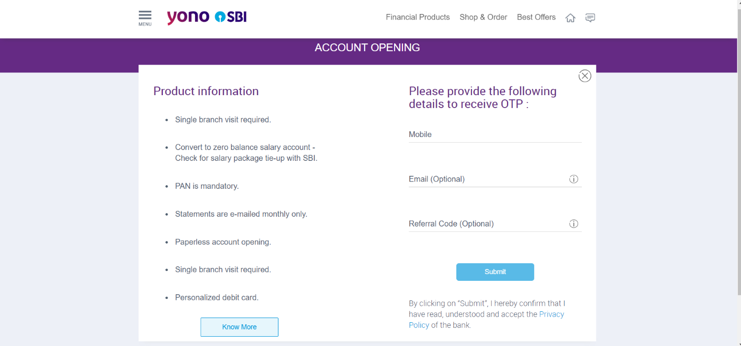

1. The user gets more benefits through the features of the chatbot like money transaction details, online money transfer options, loans, credit card application, cancellation of credit/debit card, EMI calculator and also avail the insurance policies to them which is given by the bank. The user gets these all benefits if he login at the official website of our bank.
2. The chatbot takes the data from the website, it also reminds the user to login to website by providing link of it.
3. The privacy of the information is been kept safely and no leakage of information is possible.

**OUTPUT:**

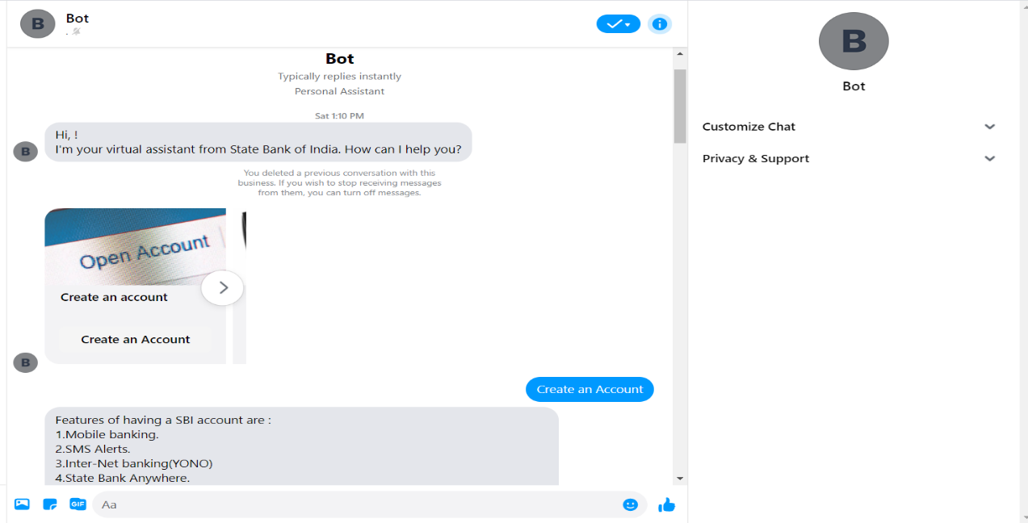

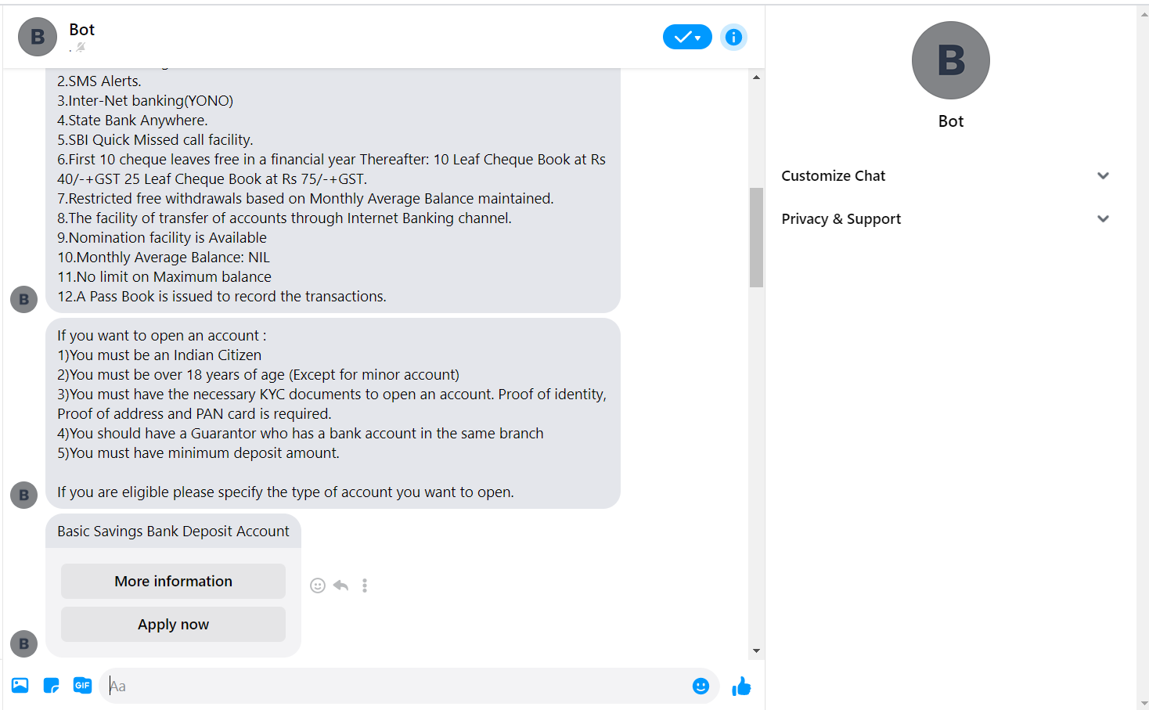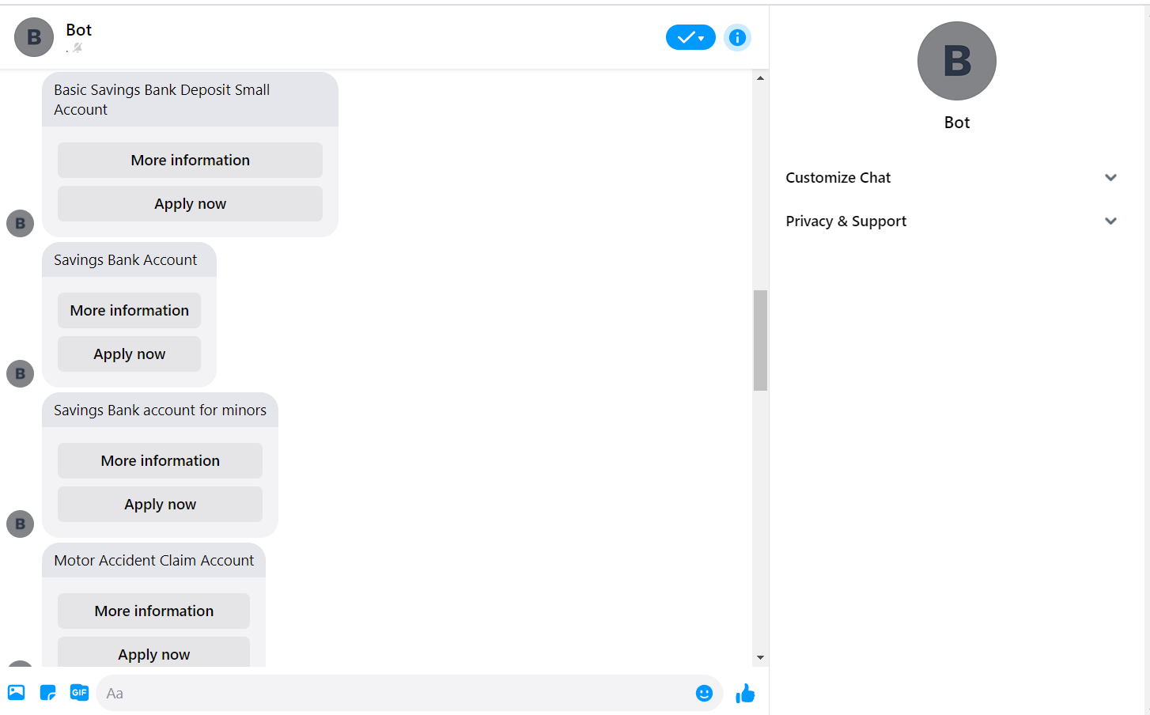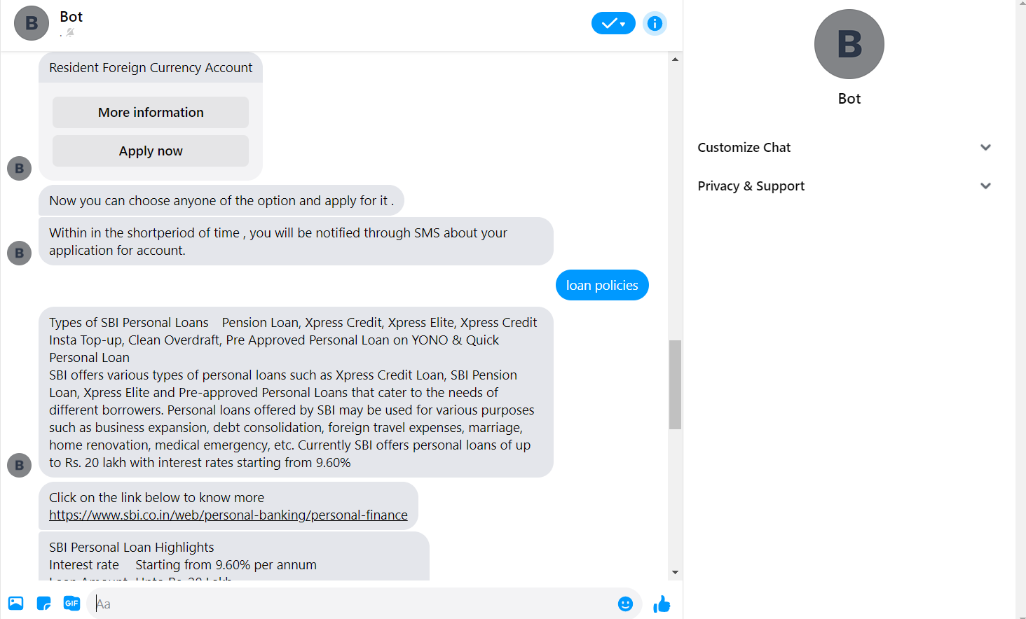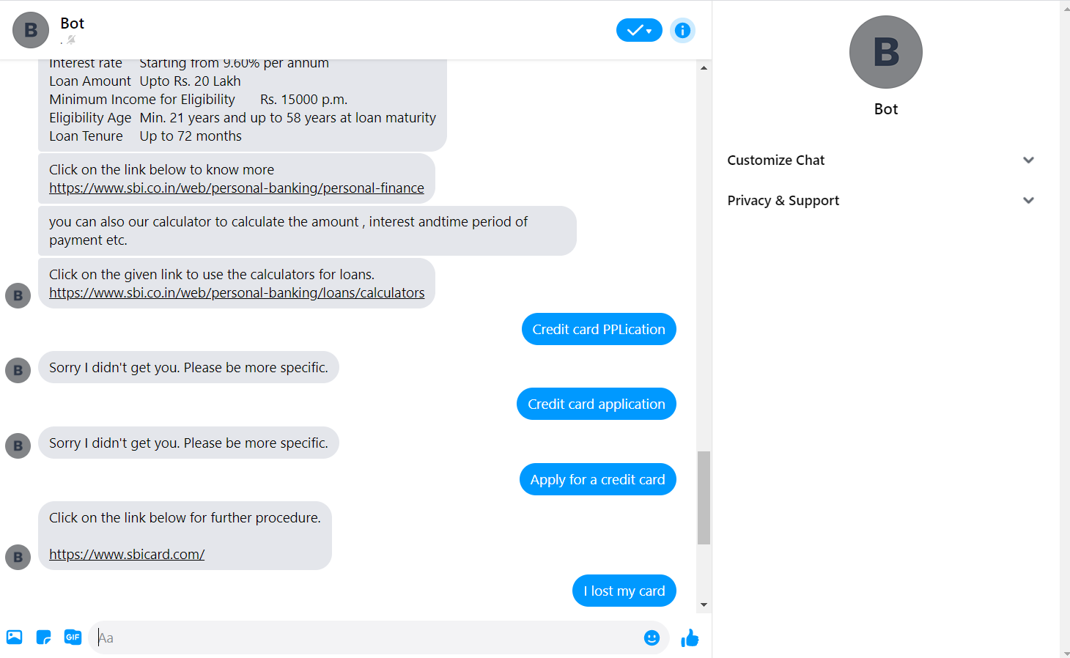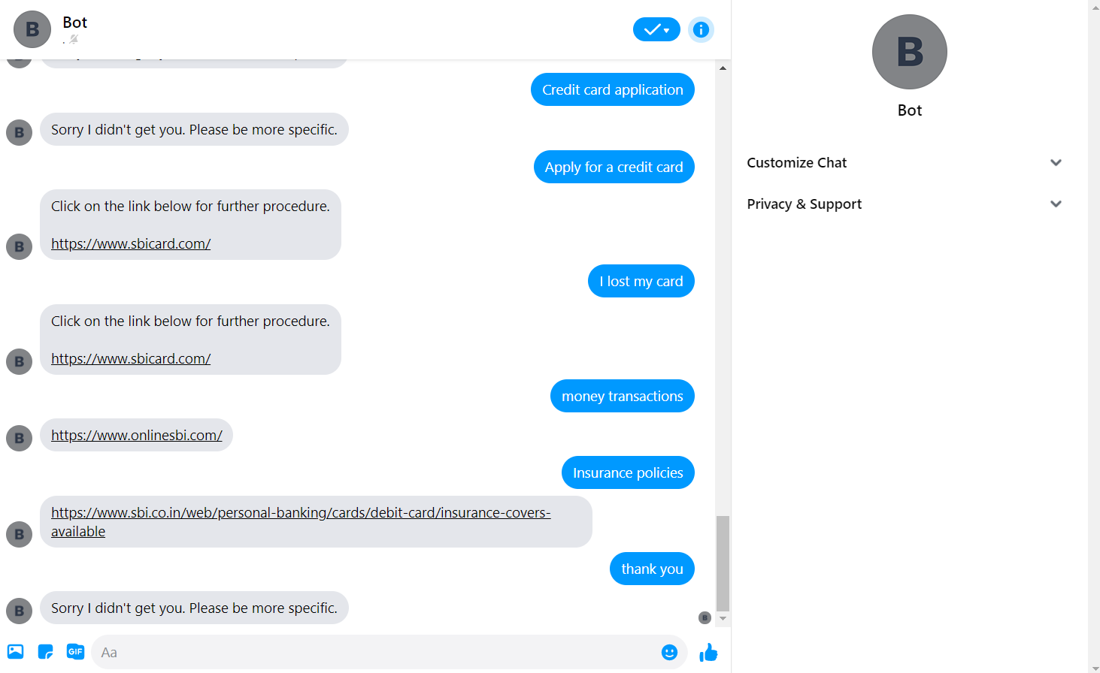

EMI calculator for loans:

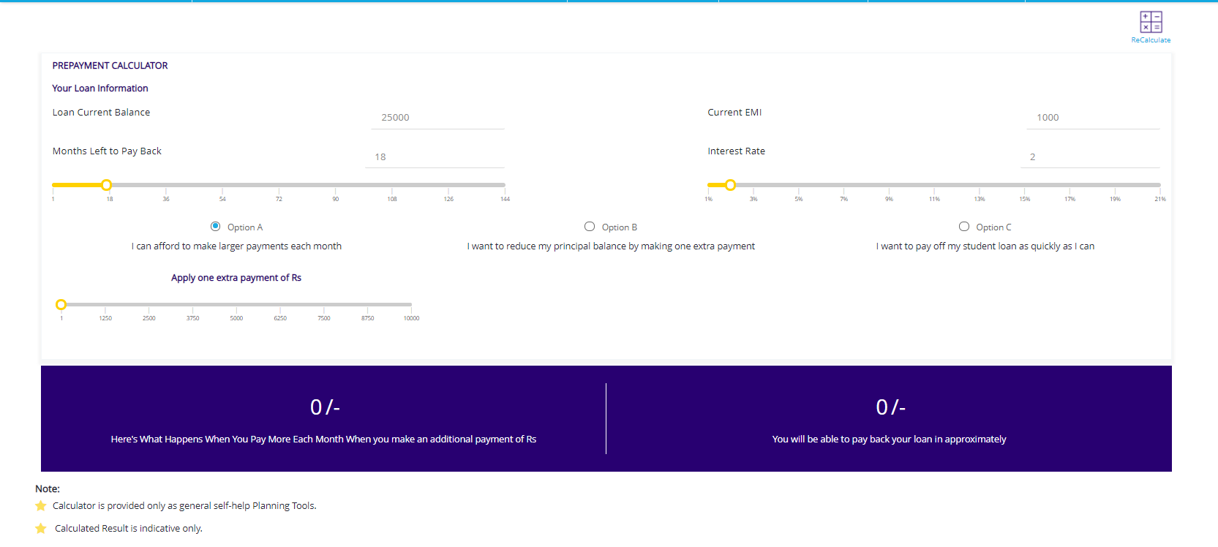Insurance Policies: the user can avail these insurance policies by applying and getting the credit card.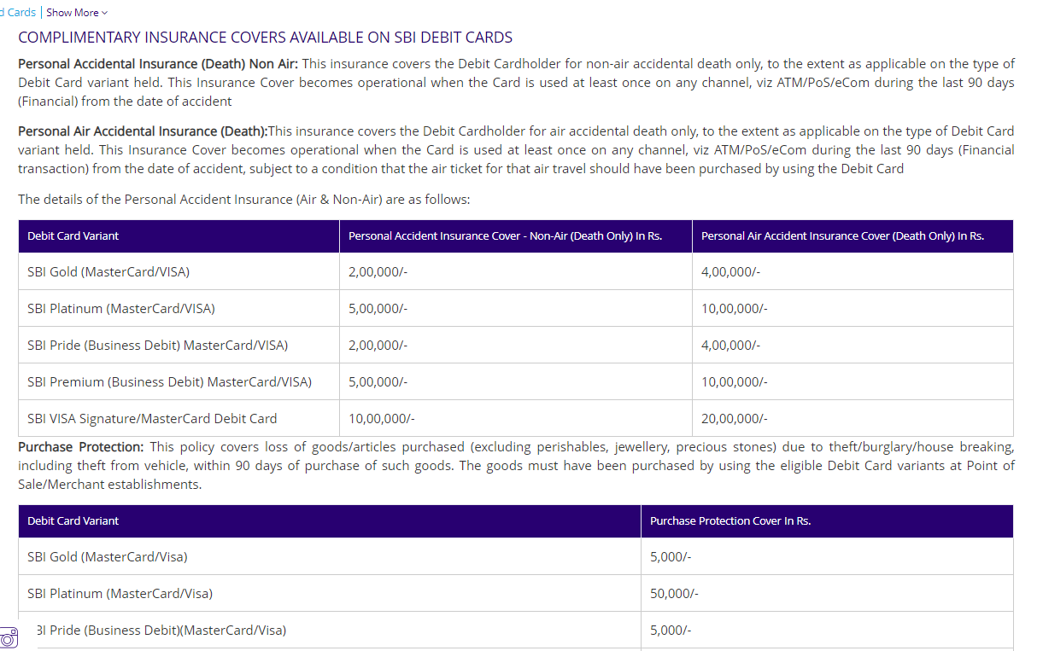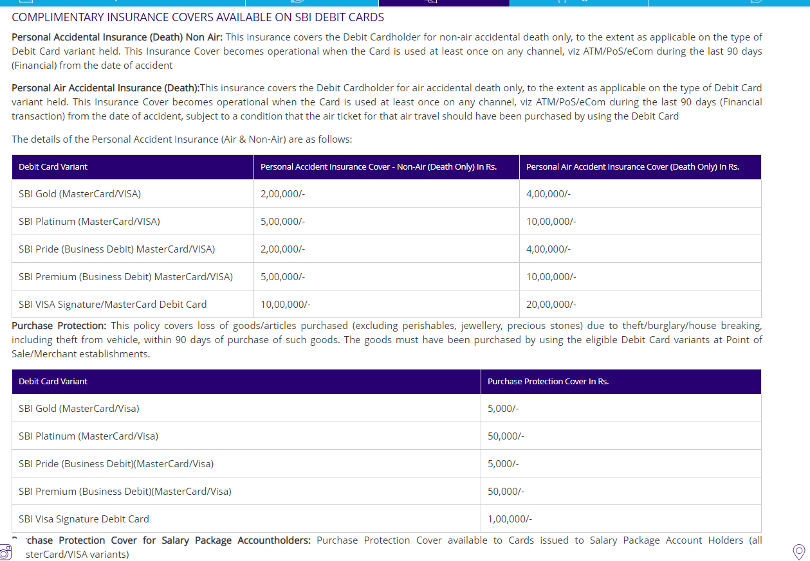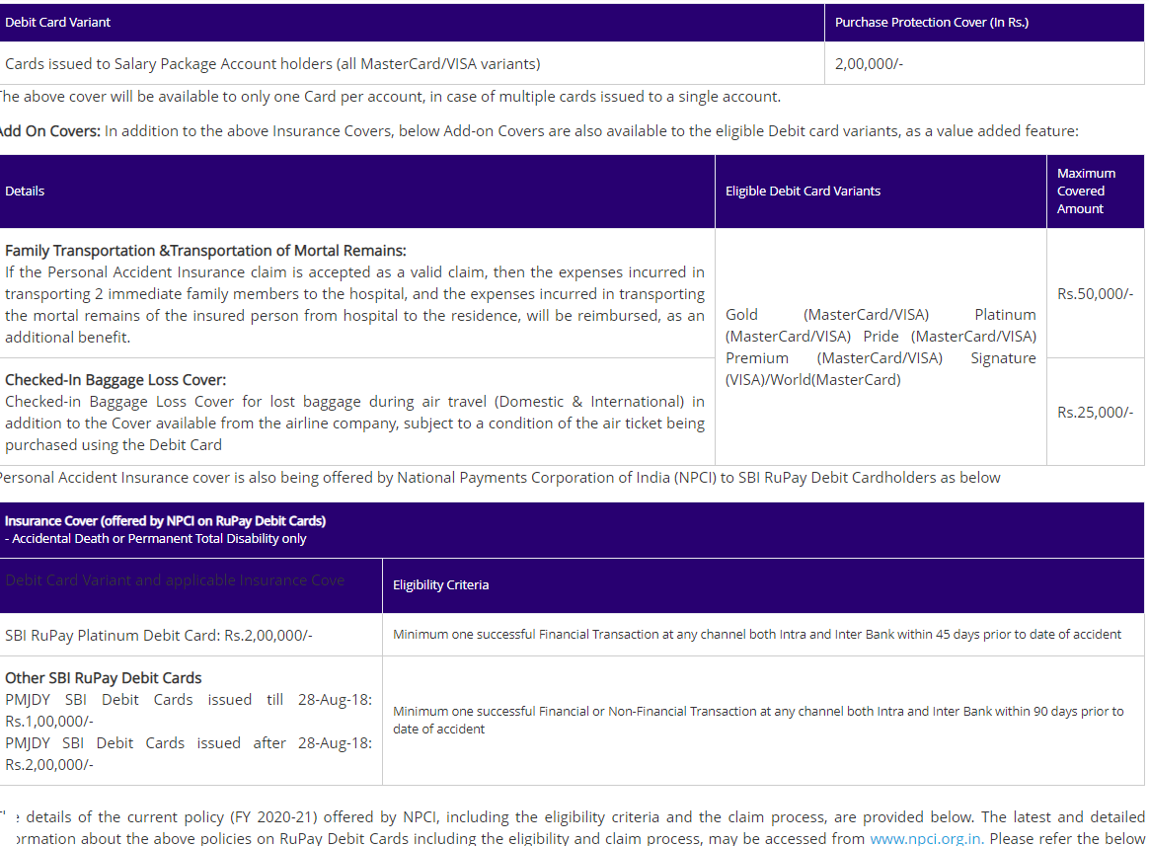

THANK YOU